
SIMATS ENGINEERING
Saveetha Institute of Medical and Technical Sciences
Chennai-602105

AQUAGUARD 360: INTELLIGENT WATER QUALITY MONITORING AND PREDICTIVE CONTAMINATION ALERT SYSTEM

S ROOPAN RAJ(192525474)
B.Tech AI&ML

DECLARATION

I hereby declare that the project entitled "AquaGuard 360: Intelligent Water Quality Monitoring and Predictive Contamination Alert System" submitted in partial fulfillment of the requirements for the award of the degree of Bachelor of Engineering in Artificial Intelligence and Machine Learning is a record of original work carried out by me under the guidance of Dr. ANITADAVAMANI, Department of Artificial Intelligence and Machine Learning, Saveetha Engineering College.
I further declare that this project has not previously formed the basis for the award of any degree, diploma, associate ship, fellowship, or any other similar title in any University or Institution.

Date /08/2026 Signature of the Student
Place: Chennai S. ROOPAN RAJ

ACKNOWLEDGEMENT
I express my sincere gratitude to Saveetha Engineering College, Chennai, for providing an excellent academic environment and the necessary facilities to carry out this project successfully.
I extend my heartfelt thanks to the Principal of Saveetha Engineering College for providing continuous encouragement, motivation, and institutional support throughout the completion of this project.
I express my sincere gratitude to the Head of the Department of Artificial Intelligence and Machine Learning for providing valuable guidance, encouragement, and the necessary infrastructure required for the successful completion of this work.
I am deeply indebted to my project guide, Dr. ANITADAVAMANI, for their constant encouragement, technical expertise, valuable suggestions, and continuous supervision throughout every stage of this project. Their guidance played a vital role in shaping this work into its present form.
I also thank all the faculty members of the Department of Artificial Intelligence and Machine Learning for sharing their knowledge and extending their support whenever required.
Finally, I express my heartfelt gratitude to my parents, family members, friends, and classmates for their unwavering encouragement, motivation, and moral support throughout the development of this project.

1. INTRODUCTION
Clean and safe water is essential for human health, agriculture, industries, and environmental sustainability. However, increasing pollution from industrial discharge, agricultural runoff, and domestic waste has made continuous water quality monitoring a significant challenge. Traditional monitoring methods depend on manual sample collection and laboratory analysis, which often delay contamination detection and increase the risk of unsafe water reaching consumers.
AquaGuard 360 is an intelligent water quality monitoring and predictive contamination alert system that combines IoT sensors, Artificial Intelligence (AI), Machine Learning (ML), and Cloud Computing to continuously monitor water quality in real time. Sensors collect parameters such as pH, turbidity, temperature, dissolved oxygen, and conductivity. These values are analyzed using AI algorithms to predict contamination and generate early alerts for water authorities.
To ensure that the application functions correctly and reliably, comprehensive software testing is required. Test case design helps verify that every module behaves as expected under normal, boundary, invalid, and exceptional conditions.

2. FUNCTIONAL REQUIREMENTS
The AquaGuard 360 system provides several functional features that must be verified during testing.
- User Login and Authentication.
- Continuous collection of sensor data.
- Storage of sensor readings in the database.
- AI-based contamination prediction.
- Real-time alert generation.
- Dashboard displaying live water quality data.
- Historical report generation.
Requirement ID | Functional Requirement
FR-01 | User Login
FR-02 | Sensor Data Collection
FR-03 | Data Storage
FR-04 | AI Prediction
FR-05 | Alert Generation
FR-06 | Dashboard Display
FR-07 | Report Generation

3. NON-FUNCTIONAL REQUIREMENTS
Apart from functional correctness, the system should satisfy several quality requirements.
- High system reliability.
- Fast response to sensor updates.
- Secure user authentication.
- Continuous system availability.
- Scalable architecture for multiple monitoring locations.
- Easy usability through an interactive dashboard.
- Maintainable and modular software architecture.
These requirements ensure that AquaGuard 360 performs efficiently even when handling continuous real-time monitoring.

4. TEST SCENARIO IDENTIFICATION
Test scenarios describe the major situations that must be verified during software testing.
Scenario ID | Test Scenario
TS-01 | Verify successful user login
TS-02 | Verify invalid login credentials
TS-03 | Verify sensor data collection
TS-04 | Verify AI prediction accuracy
TS-05 | Verify contamination alert generation
TS-06 | Verify dashboard updates
TS-07 | Verify report generation
TS-08 | Verify system behavior under invalid sensor data
Each scenario represents a real-world operation of the system and forms the basis for detailed test case development in the next section.

5. TESTING OBJECTIVES
The primary objective of testing AquaGuard 360 is to ensure that every module functions correctly under different operating conditions. Testing verifies that the application accepts valid inputs, rejects invalid data, predicts contamination accurately, and generates alerts whenever unsafe water quality is detected.
The testing process also evaluates system reliability, response time, security, and overall usability. Proper testing reduces software defects and improves confidence before deployment.

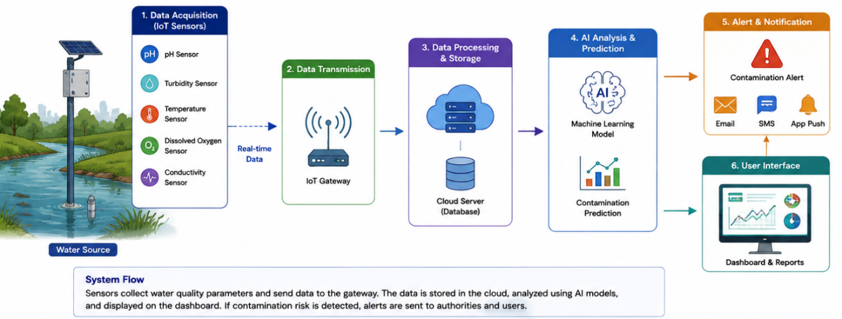

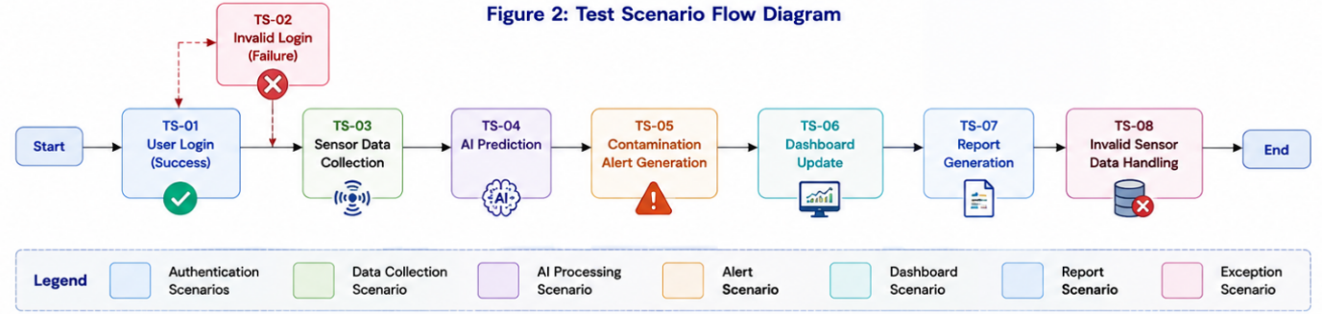

6. TEST CASE DESIGN
The AquaGuard 360 application contains multiple modules that require systematic testing before deployment. The following test cases validate authentication, sensor monitoring, AI prediction, dashboard updates, and alert generation.
TC ID | Test Scenario | Test Steps | Test Data | Expected Result |  | Actual Result | Status
TC-01 | Valid User Login | Enter valid username & password | Admin / Admin123 |  | User logged in successfully | Successful Login | Pass
TC-02 | Invalid Login | Enter incorrect password | Admin /12345 |  | Error message displayed | Error Displayed | Pass
TC-03 | Sensor Data Collection | Send sensor readings | pH=7.2, Temp=25°C |  | Data stored successfully | Stored | Pass
TC-04 | AI Prediction | Submit valid sensor values | Normal Water Values |  | Prediction generated | Safe Water | Pass
TC-05 | Alert Generation | Submit contaminated values | pH=3.5, Turbidity=120 NTU |  | Alert generated | Alert Sent | Pass
TC-06 | Dashboard Update | Refresh dashboard | Live Sensor Data |  | Dashboard updated | Updated | Pass
TC-07 | Report Generation | Generate report | Monthly Data |  | PDF Report Created | Generated | Pass
TC-08 | Invalid Sensor Data | Submit negative values | pH=-2 |  | Validation Error | Error Displayed | Pass
The above test cases verify all major modules of AquaGuard 360. They ensure that the system correctly accepts valid inputs, rejects invalid values, predicts contamination accurately, and generates timely notifications for abnormal water quality conditions.

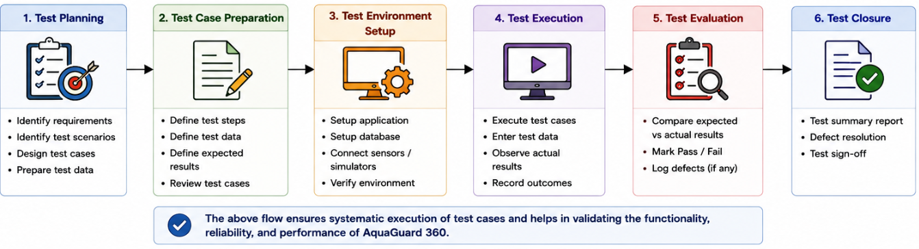

7. TEST DATA AND EXPECTED RESULTS
Different categories of test data are used to verify system behavior under various operating conditions.
Normal Test Data
- Valid login credentials
- Sensor values within acceptable range
- Valid report generation requests
Boundary Test Data
- pH = 0
- pH = 14
- Temperature = 0°C
- Maximum supported sensor values
Invalid Test Data
- Empty username or password
- Negative sensor values
- Missing sensor information
- Incorrect data format
Exceptional Conditions
- Database connection failure
- Network interruption
- Sensor communication failure
- AI prediction service unavailable
The expected result is that the application should process valid inputs correctly while displaying meaningful validation messages for invalid or exceptional situations without affecting overall system stability.

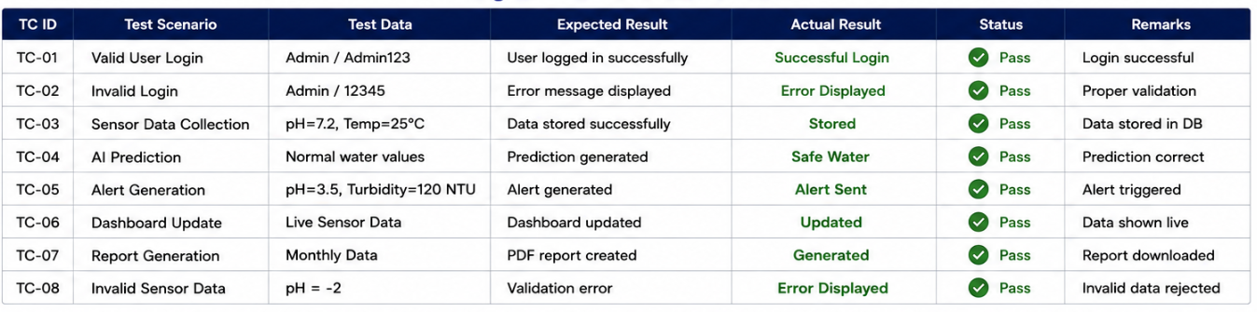

8. TEST EXECUTION SUMMARY
The designed test cases successfully validate all major functionalities of AquaGuard 360. Functional testing confirms that user authentication, sensor monitoring, AI prediction, dashboard visualization, and report generation perform as expected.
Boundary testing verifies system behavior at minimum and maximum input limits, while invalid input testing confirms that appropriate validation messages are displayed without causing application failure. Exceptional condition testing further demonstrates that the system remains reliable even during abnormal operating conditions.
Overall, the testing process provides confidence that AquaGuard 360 is functionally correct, reliable, and ready for deployment in real-world water quality monitoring applications.

9. TEST DESIGN TECHNIQUES
To improve the effectiveness of testing, standard software testing techniques are applied while designing the test cases.
9.1 Equivalence Partitioning (EP)
Equivalence Partitioning divides the input values into valid and invalid groups. Instead of testing every possible input, one representative value from each group is selected.
Example
- Valid pH Range → 0 – 14
- Invalid pH Range → Below 0 or Above 14
This technique reduces the number of test cases while maintaining effective coverage of the application.

9.2 Boundary Value Analysis (BVA)
Boundary Value Analysis verifies system behavior at the minimum and maximum limits where software defects are most likely to occur.
Examples:
Parameter | Boundary Values
pH | 0, 1, 13, 14
Temperature | 0°C, 50°C
Turbidity | Minimum & Maximum Value
Testing these boundary values ensures that the application correctly handles extreme input conditions.

9.3 Decision Table Testing
Decision Table Testing validates system behavior for different combinations of input conditions.
Sensor Status | Prediction | Expected Action
Normal | Safe | No Alert
High Turbidity | Unsafe | Generate Alert
Missing Data | Unknown | Display Error
This technique verifies that every possible decision outcome is handled correctly.

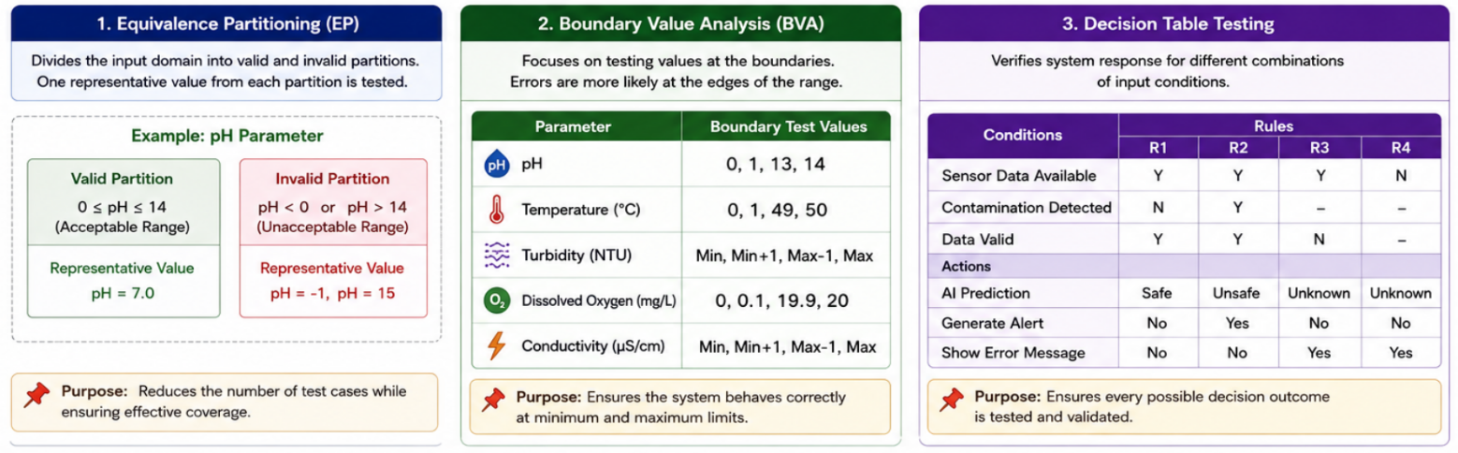

10. REQUIREMENT TRACEABILITY MATRIX (RTM)
The Requirement Traceability Matrix maps every functional requirement to one or more test cases. It ensures complete requirement coverage and confirms that no functional requirement has been left untested.
Requirement ID | Requirement | Test Case
FR-01 | User Login | TC-01, TC-02
FR-02 | Sensor Data Collection | TC-03
FR-03 | AI Prediction | TC-04
FR-04 | Alert Generation | TC-05
FR-05 | Dashboard Display | TC-06
FR-06 | Report Generation | TC-07
FR-07 | Invalid Data Validation | TC-08
The RTM confirms that each requirement is mapped to at least one corresponding test case, ensuring complete functional verification.

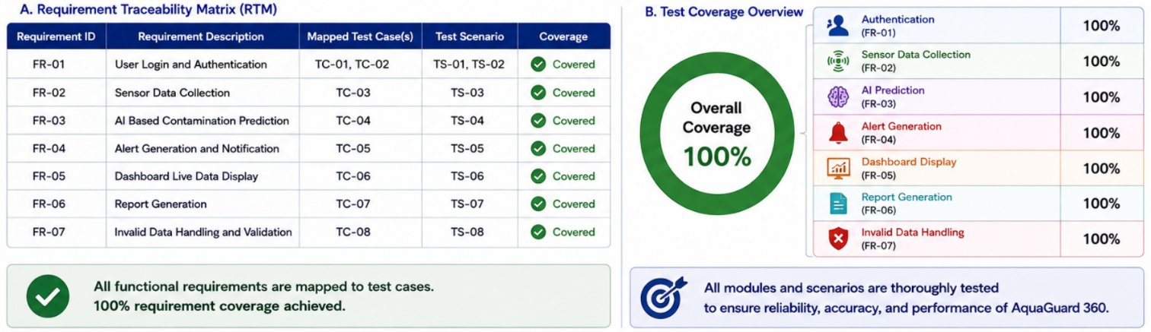

11. CONCLUSION
The test case design prepared for AquaGuard 360 provides systematic verification of all major functionalities of the application. Functional and non-functional requirements were identified, relevant test scenarios were created, and comprehensive test cases were designed to validate normal, boundary, invalid, and exceptional conditions.
The application of Equivalence Partitioning, Boundary Value Analysis, and Decision Table Testing improves the effectiveness of testing while reducing redundant test cases. The Requirement Traceability Matrix confirms that all functional requirements are completely covered.
Overall, the designed test cases indicate that AquaGuard 360 is reliable, secure, and capable of performing continuous water quality monitoring with accurate AI-based contamination prediction.

REFERENCES
- Ian Sommerville, Software Engineering, 10th Edition.
- Roger S. Pressman, Software Engineering – A Practitioner's Approach, 9th Edition.
- IEEE Software Testing Standards.
- ISTQB Foundation Level Testing Syllabus.
- AquaGuard 360 Project Specification.

